**Sabir Hussain**

**Data Science (batch 3)**

**Group 02**

**Task 1: An Introduction to Git.**

(This will include installing Git and learning some basic commands: init, add, and commit, etc.)

**Downloading Git:**

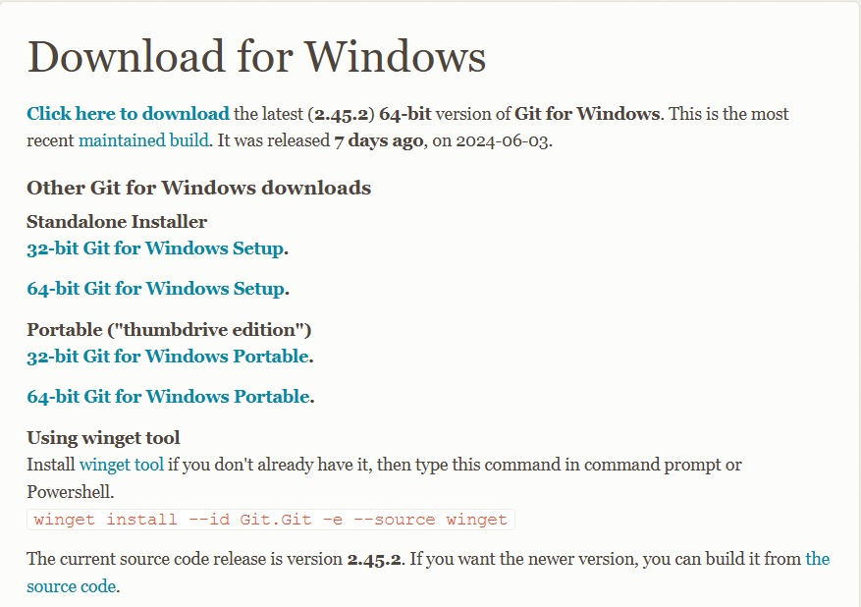

**Installing Git:**

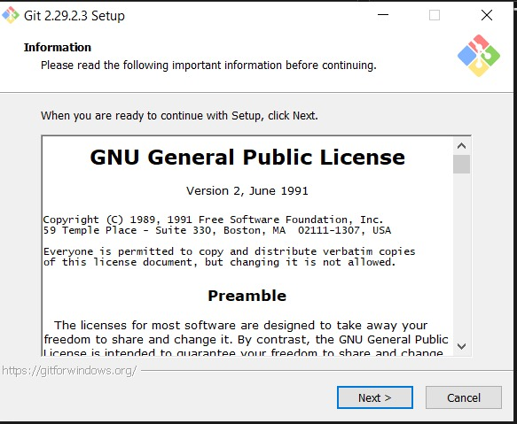

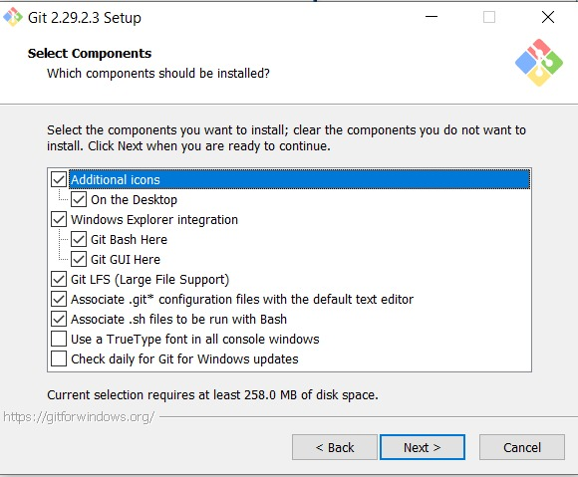

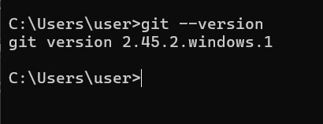

**Running Basic Commands:**

* **git init:** Initialize a new Git repository.

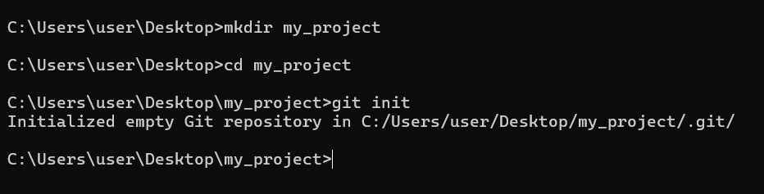

* **git add:** Add files to the staging area.

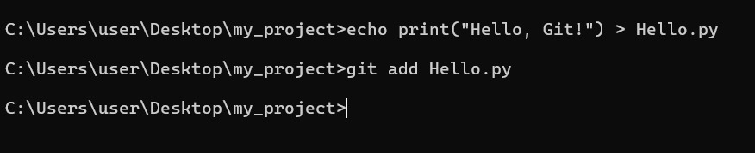

Before running the commit command, we must configure our username and email account.

* Configure name and email:

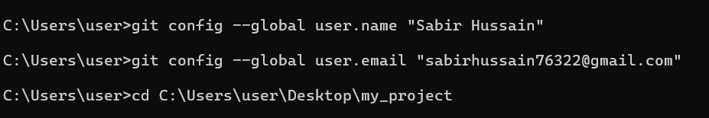

* **git commit:** Commit your changes to the repository.

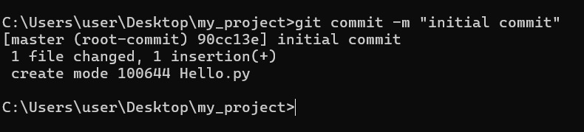

* **git log:**

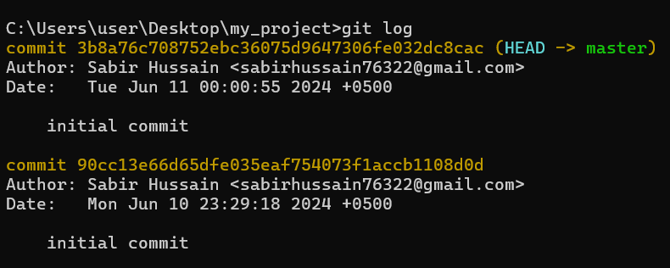

* **git status:**

* **git branch:**

